**Introduction to DevOps: Simplified with a Real World Non-IT Example**

What is DevOps?

At its core, DevOps is about improving collaboration between development (the creators) and operations (the maintainers) with a goal to shorten the system development life cycle and provide continuous delivery of high-quality software.

**The Non-IT Analogy: Building a House**

Let’s use the process of building a house as a metaphor to better understand DevOps.

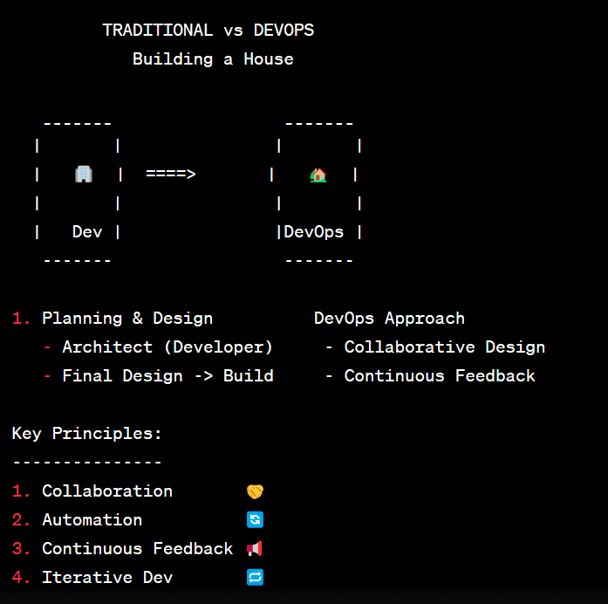

**Planning and Design (Traditional Development Process)**

Imagine you want to build a house. The first thing you do is approach an architect (developer). The architect drafts a design based on your requirements. Once the design is finalized, it's handed over to the construction team (operations) to turn it into a reality.

However, if there are issues or misunderstandings, the construction may not go as planned, causing delays, increased costs, and potentially a home that doesn’t meet the original vision.

**DevOps Approach**

Instead of waiting for the final design, the architect (developer) collaborates closely with the construction team (operations) from the start. After sketching a room, they might discuss feasibility, get immediate feedback, and make instant changes. This collaboration ensures:

* **Fewer misunderstandings**
* **Faster problem resolution**
* **A final product closely aligned with the original vision**

**Core Principles of DevOps in the Context of House Building:**

Collaboration: Just like the architect working closely with the construction team, developers and operations work together throughout a project. They share responsibilities and combine their workflows to avoid handoff delays.

Automation: In our house-building example, consider using pre-fabricated materials or modern construction techniques. These methods can speed up the building process, reduce errors, and ensure consistency. In software, automation tools help in code integration, testing, and deployment, making processes faster and more reliable.

Continuous Feedback: Just as the homeowner would inspect and give feedback during the construction of the house, in DevOps, continuous monitoring and testing provide real-time feedback about the software's performance, usability, and potential issues.

Iterative Development: Instead of building the entire house at once, maybe it starts with a single room or section. Feedback from this first build can inform subsequent parts of the project. Similarly, DevOps promotes iterative development, releasing smaller features more frequently to catch issues early and make improvements continuously.

**Why Adopt DevOps?**

Adopting a DevOps culture, like the collaborative approach in our house-building example, offers several benefits:

Faster Delivery: Faster construction or quicker software release.

Better Quality: Fewer defects and issues because of continuous testing and feedback.

Improved Collaboration: Reduced misunderstandings and smoother workflows.

Higher Efficiency: Automation reduces repetitive tasks and potential for errors.

**In Conclusion**

DevOps isn't just a buzzword in the software industry. It's a cultural shift that promotes collaboration between development and operations, ensuring faster and more reliable software delivery. By drawing parallels with building a house, we see how essential collaboration, feedback, and iterative practices are in producing outstanding results in any field.